Semantic web
A web of data that is machine readable
data annotation
RDF is a way to annotate
Resource Description Framework
subject -predicate> object
URI (Uniform Resource Identifier)
IRI (International Resource Identifier)
URL (Uniform Resource Locator)
Inference mechanism (Rules to generate relationships in RDF graph)
Protégé is the a way of coding RDF graphs

SPARQL is a way of searching RDF graphs
Sparql has 3 parts,
BASE and PREFIX
for defining shorthands for some link

SELECT / SELECT DISTINCT
what you want back from your searching

WHERE and FILTER
for defining a pattern that you are searching for where you name parts of the pattern so that it matches the SELECT part

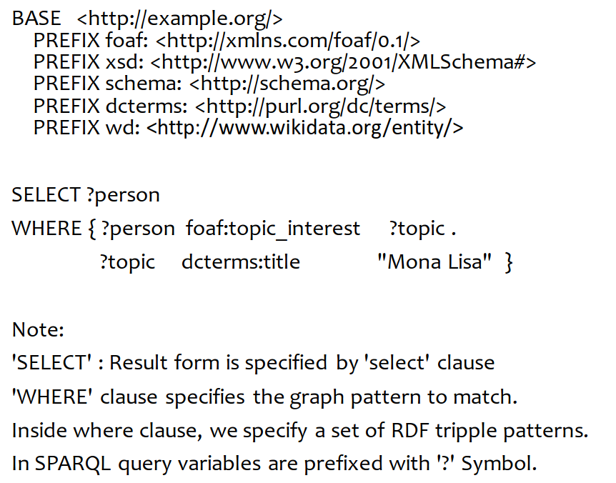
example:

RDF visualized:
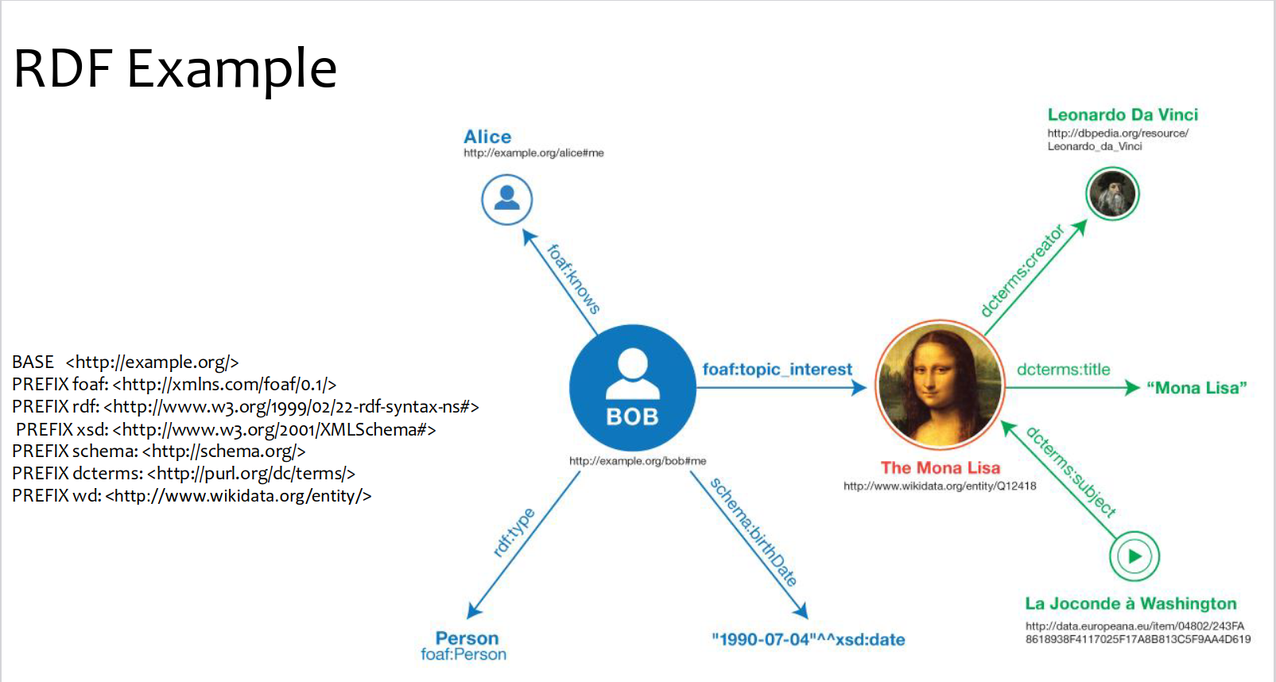
Wikidata has a query service where you can use ctrl+space to search for wikidata lables instead of copy paste from Wikidata website

